Kian Agheli
ENGL 202
21 November 2025

Introduction
The late ’80s and ’90s transformed the nascent hip-hop genre into the pubescent form of rap. During this time, anything and everything was possible for this distinctly Black American mode of expression. Popular hip-hop songs such as The Sugarhill Gang’s “Rapper’s Delight”, and Doug E. Fresh’s “La Di Da Di” (vocalized by the artist to be focused on today), became a mode of expression for popular fantasies among males of the time and places: dreams of riches, sexual liberty, and an utter lack of responsibility to match. Leading into the ’90s, variations on these themes were what people wanted to hear. Where hip-hop was about beats and rhythm, rap was about beats, rhythm, and the adolescent dreams of males. Hip-hop died, and rap replaced it, so these themes were what people wanted to hear variations of.
Early rap music is a category of artifacts of Black English, of many varieties. The work to be studied here is of an influential artist with a complex matrix of influences. Slick Rick is an artist born to Jamaican parents who grew up in London until age 11, then migrated to New York. As his time in The Big Apple continued, his mix of dialects slowly reduced to the one he was surrounded by; that said, his album The Ruler’s Back was recorded leading into 1991: during this time, he maintained features in his speech of multiple dialects of English. His grammar, erudition, and some features of his pronunciation were indicative of a dialect of English with some of the aristocratic connotations of Received Pronunciation. His choice of words, cultural associations, and select features of his pronunciation were distinctly of New York English as spoken by Black people in the Bronx. The music under study is an artifact of atypical mixture of influences: BE as spoken within the context of NYE, and features of RP present in South London.
The particular songs chosen for study are of special social significance. The artist’s music The song “Top Cat” builds on themes prevalent in the rap music of the day: misogyny, male dominance, and egomaniacy. Using a humorous framing, it presents these issues in an unusual light, an interesting perspective highlighted by the artist’s witty mix of dialects. The song “Moses” tells the story of the character from the Old Testament the song is named after. The artist versifies new intrigue into a two-thousand year-old story which forms a foundational element of several popular world religions. The connotations of these stories called into question prevalent sentiments of the time and place.
Phonetic Transcription

Phonetic transcription of the first four lines of “Top Cat”.

Eatin’ a bit and nap, human being make way spittin’
itɪŋ ə bɪt ænd næp humɪn biŋ mek we spɪtɪŋ
As I’m skippin’ through an alley in New York, a stray kitten
æz eIm skɪpɪŋ θru ɪn æli ɪn nju jork ə stre kɪtɪn
Dog chase couple of blocks (shocked), tough being a fox
dɔg ʧes kəpl əf bloks ʃɔkd təf biŋ ə foks

He in a tux, some good samaritan’ll stuff me in a box
Hi ɪn ə təks səm gʊd səmɛrɪtænl stəf mi ɪn ə boks

Phonetic transcription of the first four lines of “Moses”

As you see Ruler shows his inquiring noses
æs ju si rulr ʃows hɪz ɪnkwereŋ nosɪz

Going into a story about a kid named 'Moses'
goɪn ɪntu ə stori əbaʊt ə kɪd nemd mosɪs

Once a prophet was to be born, so ’fore anything else furthered
wəns ə prɔfɪt was tu bi bour sɔ for aniθɪŋ ɛls fərðərd

Pharoah orders every first-born son murdered
faro ordərs ɛvɛri fɪrst born sən mʊrdərd

Transcribed as dictated by the document (International Phonetic Alphabet (updated)).

Features of this artist’s pronunciation originating from his time in London are best expressed by markers for phonetic stress. Where a native speaker of American English may pronounce Moses as “moˈsɪs”, this artist pronounces it as “mˈosɪs”.
“ɪŋ”, oks”, “ɪz/ɪs”, “ðərd/dərd” word endings used to form line-ending rhymes.
Sentence Structure and Analysis

Top Cat

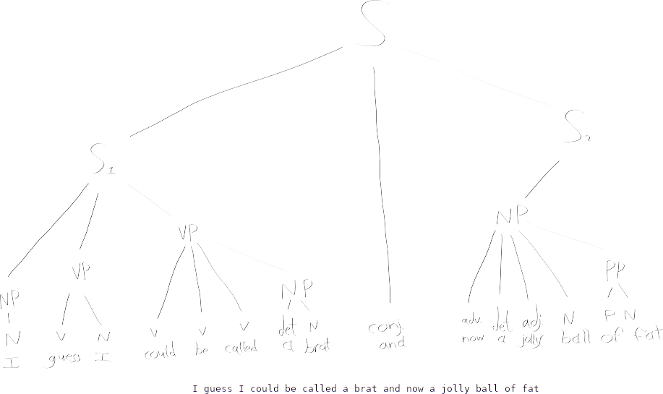
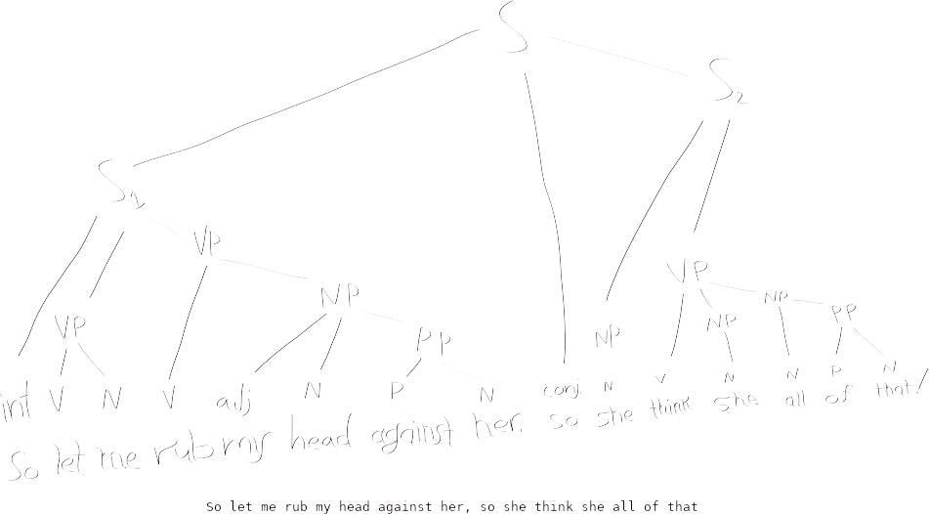
S₂ contains no verb. The verb phrase “could be called” is effectively connected to S₂.

The word “so” performs a unique function in each of its two instantiations. The definite article “that” and the form of the copula “is” are dropped from what would be the Standard English form of the phrase “she think she all of that”.
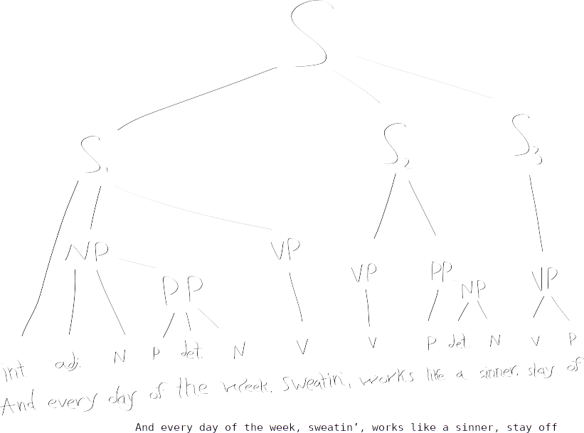
The first comma implicitly the place of the subject of the sentence and the copula.
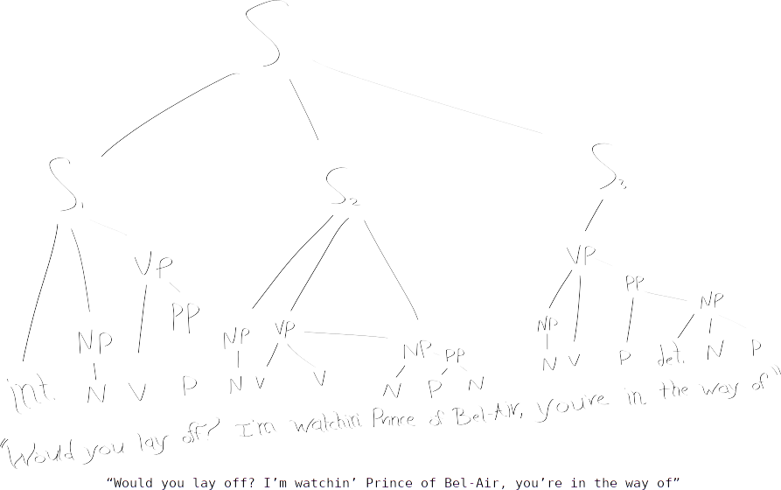
A section of dialogue, containing an interrogative sentence, as discussed in (Types of Sentences). The indirect object to the form of the copula “’re” in S₃ is implicitly the same as the subject specified at the start of S₂, “I”.
Diagrammed as specified in (Phrases and Sentence Diagrams).

The artist’s narratives are event-driven. Each sentence is in active form, largely tensed to the present (The Subtle Power of Language (abridged)).

Sociolinguistic Analysis
“Top Cat” is a reframing of several themes prevalent in the rap music of the early ’90s.
The premise of “Top Cat” says a lot about the evolution of gender roles as perceived by the artist. In a dream world where the artist becomes a cat, he remains unable to escape the toxic masculinity he knows. Within the context of a story about a cat with a superiority complex, a sense of humor reveals itself: surely, the cat who’s “just a jolly ball of fat” does not fit our typical sense of a dominant male, nor is he likely to be taken very seriously. Calling into question the assertions of this cat naturally flows to a question of all such assertions. Slick Rick makes fun of the culturally-induced misogyny he’s surrounded by (consider tropes of rap music), in a way that is in good humor, and may go over the head of a one-time listener.
“Moses” is a retelling of that very character’s story in the Old Testament. The typically staid connotation of this story is disrupted by a modern style of oral storytelling.
A variety of words and idioms used in these song have connotations specific to New York English. (The Subtle Power of Language (abridged)).
Though in seldom use, the artist has access to and does use what would be considered archaic constructions in NYE which he is comfortable with via his exposure to RP. From “Moses”, the construction “Curious I suppose this” is exemplary. In the same song, the clause “poor villain”, lacking both a definite article and a verb, is a construction supported by British dialects of English better than by NYE.
Conclusion

The songs analyzed here provide insight into features of two dialects of English.
They are both an acknowledgement and a criticism of the culture surrounding NYE.
They leverage constructions particular to each of the dialects the artist was exposed to.
Sources

Rick, Slick. (1991). Moses. The Ruler’s Back. https://www.youtube.com/watch?v=T_rIbhzhZds
Rick, Slick. (1991). Top Cat. The Ruler’s Back. https://www.youtube.com/watch?v=YuYBOVrVo2Y

IPA handout
Dialects

